Insights from Initial Implementation of the Personal Knowledge Vault:

The personal knowledge vault makes it easy to capture, store, curate and retrieve knowledge now matter where or how its stored. Its like reading glasses for your mind.

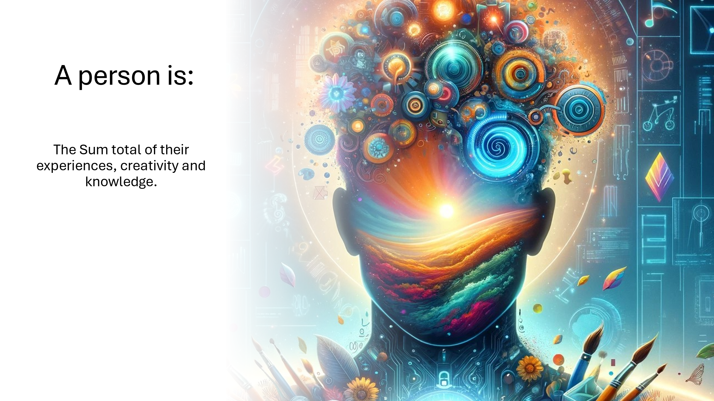

# The Challenge:

Accessing the knowledge that we need through the course of our work or in our personal lives has become incredibly complex. Whether its knowledge we have created, knowledge we need to decide or knowledge we are synthesizing for others, what used to be a relatively straightforward process now involves navigating a complex ecosystem of walled gardens of clouds and apps all competing for our data.

Each of these has its own authentication, user interface, unique ways of describing and storing knowledge making it incredibly for the average user to work with, much less someone who may be facing functional memory impairment.

The challenge is the same regardless of whether you are a single person, or part of a large organization, you have to do a lot of work to first find the right place to store the files you are working on, and even more work to find them again.

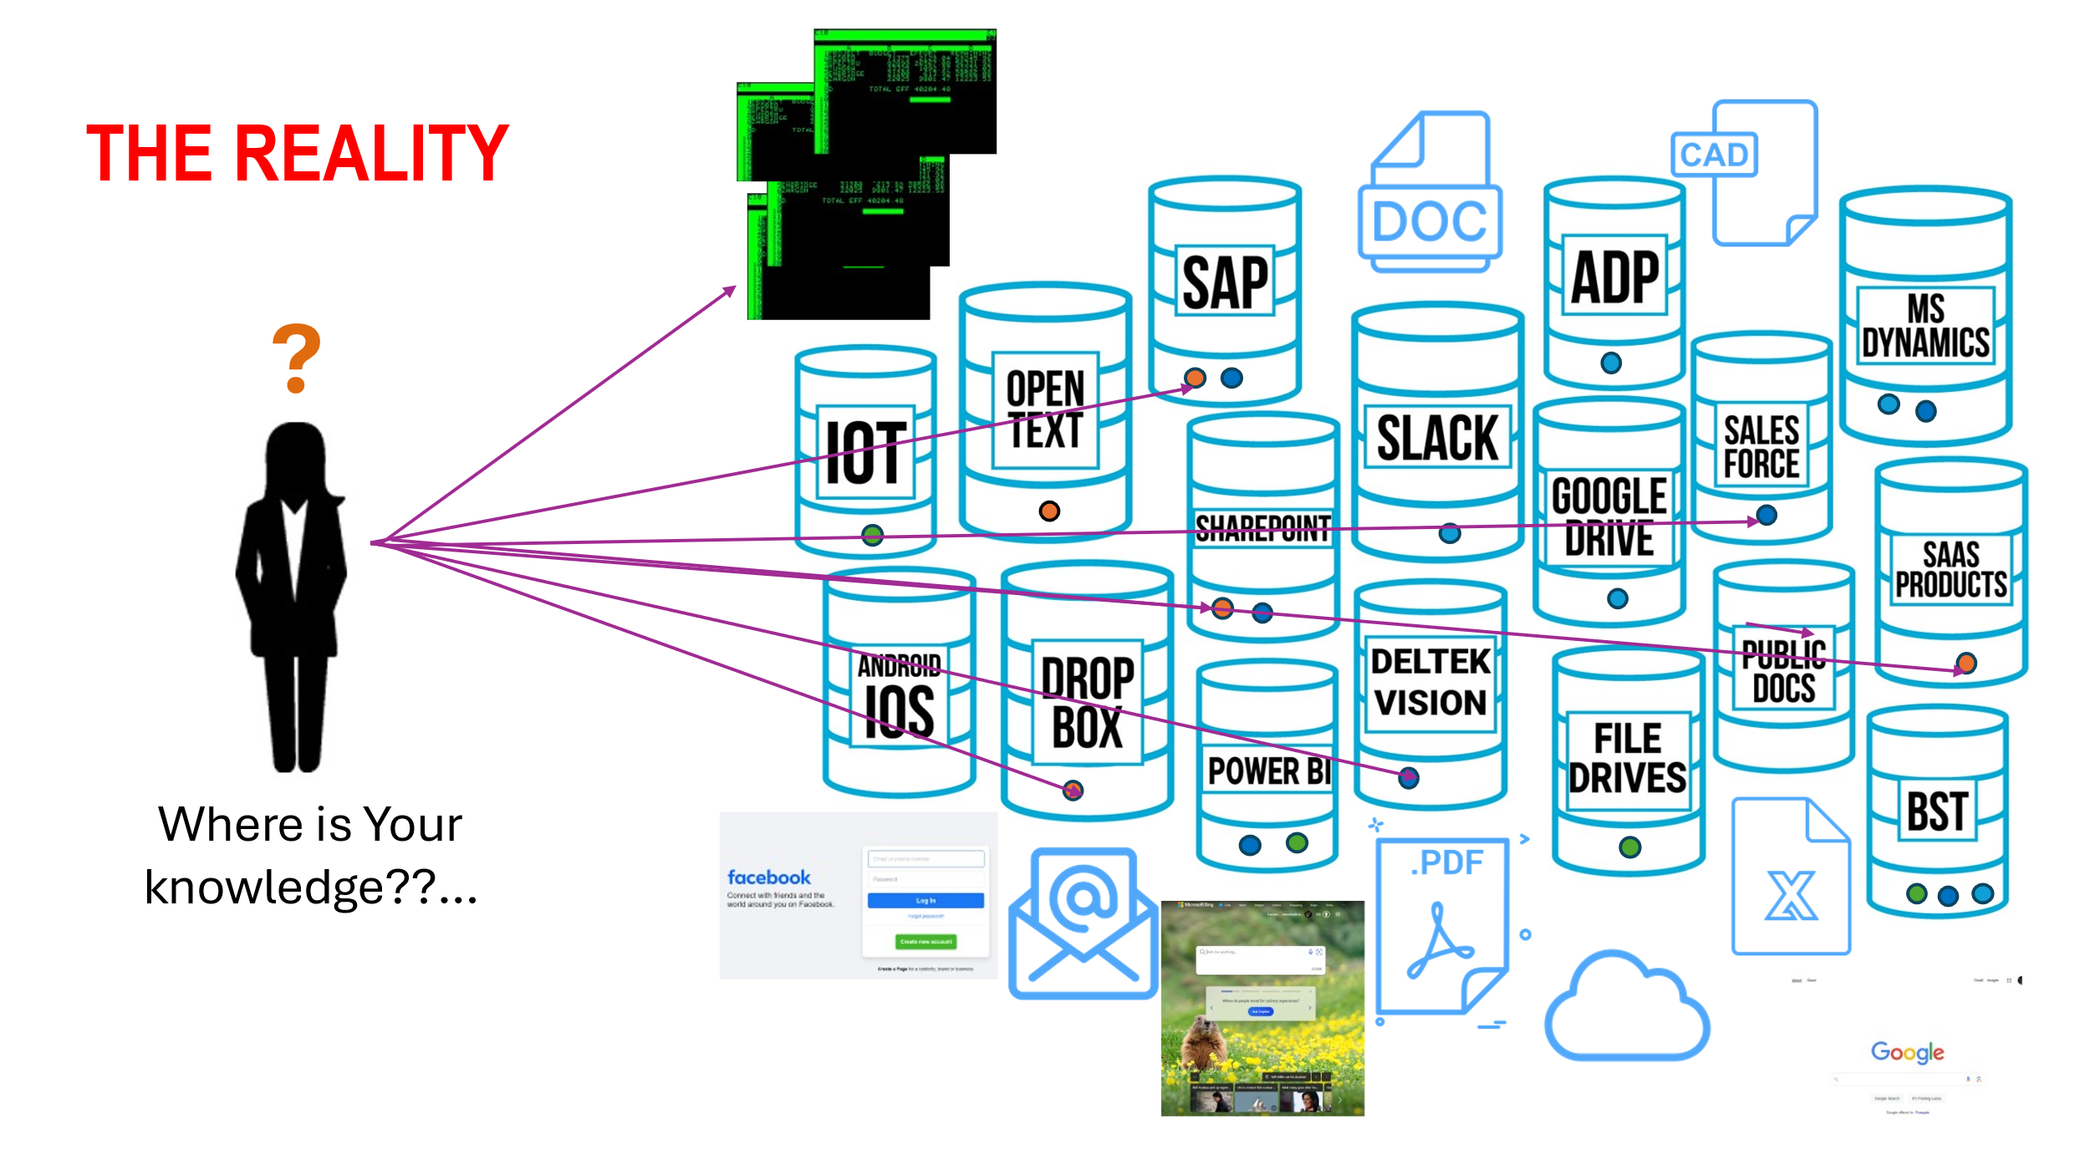

While major device and cloud providers are taking steps to address this complexity, it is still being done in a way that attempts to lock users into their version of the walled garden: great if you happen to exist entirely in their ecosystem but exacerbates the complexity as soon as you step outside the fence.

According to DataProt and BuildFire, the average smartphone user has about 80 apps installed, but they only consistently use around 9 of them and revisit 30 each month​ ([DataProt](https://dataprot.net/statistics/how-many-apps-does-the-average-person-have/" \t "_blank))​​ ([BuildFire](https://buildfire.com/app-statistics/" \t "_blank))​.

In contrast, statistics from Techjury.net indicate that while the average smartphone user has about 40 apps installed, the majority of their time (89%) is spent on just 18 of these apps​ ([Techjury](https://techjury.net/blog/app-usage-statistics/" \t "_blank))​. Additionally, younger generations, such as Millennials and Gen Z, tend to download and use more apps than older generations.

If we then consider the number of apps a person needs to work with in the context of their jobs, the number increases substantially.

The complexity of accessing and managing knowledge in our work environments has grown exponentially. On average, a company uses about 254 applications, with larger enterprises using around 364 applications. Despite this vast array of tools, regular usage remains low, with only about 45% of these apps actively engaged by employees​ ([Productiv](https://productiv.com/blog/saas-statistics-that-every-it-manager-should-see/" \t "_blank))​​ ([Business Wire](https://www.businesswire.com/news/home/20210915005244/en/Less-than-Half-of-Company-SaaS-Applications-Are-Regularly-Used-by-Employees))​. Departments typically use 40 to 60 different tools, with Security, Engineering, and IT departments using the most​ ([Business Wire](https://www.businesswire.com/news/home/20210915005244/en/Less-than-Half-of-Company-SaaS-Applications-Are-Regularly-Used-by-Employees))​. This plethora of software solutions, often managed independently by employees rather than IT departments, creates significant challenges in integration and management. Around 38% of companies identify the integration of siloed applications and data as a major obstacle to digital transformation​ ([elastic.io](https://www.elastic.io/enterprise-application-integration/application-integration-statistics/))​.

The net of this is that the basic process of creating, storing and retrieving knowledge is still far too complex for the average user, much less someone who is having challenges with their functional memory.

This proliferation of applications highlights the urgent need for AI to simplify user interfaces and streamline interactions. AI can play a crucial role in addressing this complexity by providing more intuitive and seamless user experiences.

However, the approach cloud and device makers have taken to integrating powerful AI technology into their offerings is clearly also being driven by overriding commercial interests, which results in design choices that favour corporate interests over the user’s well being.

There is clearly therefore a need for a new approach to address the challenge of complexity through harnessing AI outside the bounds of traditional cloud and device vendor walled gardens.

# The Research:

The Personal Knowledge Vault is a research project whose objective is to explore the application of AI to radically simplify users’ ability to find, discover and work with their personal knowledge while ensuring security and privacy. I am developing AI Knowledge Agents that can automatically store and retrieve Knowledge Assets without the user having to deal with the complexity of where and how to store them.

I have an MVP now operational using a GTP in ChatGPT that is connected to a custom, cloud hosted, secured API backed by a knowledge graph. I spent time with a user to validate the basic hypothesis:

“AI Agents will make it easy for a user to create, store and retrieve basic Knowledge Assets such as Articles, Documents and Notes.”

Based on the initial testing, I was able to demonstrate that the user can much more fluidly and rapidly do the following:

* Capture notes from sources such as books, handwritten notes or using voice transcription
* Add articles found on the internet to the knowledge vault
* Direct the Knowledge Agents to perform research and generate summarized versions of the research
* Retrieve these Knowledge Assets by asking questions
* Retrieve word documents stored in the Knowledge Vault by asking questions relating to the subject being exploring
* Capture and store memories

# Limitations and challenges that were identified:

While the system demonstrably improved the user’s ability to interact with their knowledge in a new and far simpler manner, there are still considerable challenges to overcome.

* Fully text base user experience using chatGTP does not give user enough information for Discovery – i.e. browsing or moving through the Knowledge Vault’s contents. A hybrid mode where a suitable visual interface that is driven by AI agent interactions is needed.
* Answers don’t always catch the correct Knowledge in terms of finding specific documents or notes – more context is needed in the graph to improve this and/or better search/matching strategies
* Agents that inspect incoming knowledge and build relevant context in the graph to more fully qualify the Knowledge Assets is needed. This should be done though by informing the agent curation strategy based on the user’s profile. For example, a user who is an engineer would have very different interests than someone who is a priest or an accountant. The agents must take insights from the user and apply them to effectively classify the knowledge assets for future retrieval.
* The system needs to an agent on the user’s laptop. Users often store files in a very disorganized manner spread across many different file folders, file storage systems etc. Providers such as Apple, Microsoft and Google make the problem worse by trying to pull users into their respective clouds.
* Helping the user to manage passwords and accounts associated with the knowledge systems

# Lessons Learned When Implementing AI Knowledge Systems:

An objective of this project is to help understand what is needed to create a successful implementation of Retrieval Augmented Generation based LLM knowledge system. The lessons learned in the context of this MVP are observational and empirical with a group of three users. They are informative though in terms of general observations about the efficacy of the technology and approach that can be used to inform subsequent developments or other MVP initiatives.

## The Technology Does not remove the need for data modelling

While LLMs and Retrieval Augmented Generation provide a powerful set of capabilities for finding and discovering knowledge that has been historically trapped in files and other unstructured sources, it does not mean you can simply drop the technology on a sharepoint document library and expect it to work.

For small content repositories such as large PDF files or limited libraries that are all on a specific subject, the amount of pre-processing required will certainly be less. Good results can be had with a simple setup and limited thought put into the decomposition of the documents into the ‘chunk’ form required to facilitate Retrieval Augmented Generation (RAG).

However, as the number of documents increases, other factors come into play. At its core RAG still relies on embedding based similarity matching. While this provides better results than basic full text query term matching, it still has limits as the knowledge repository complexity increases.

This is why basic vector only databases may work well with limited scope libraries but start to miss more as the knowledge scope increases to encompass more domains.

## Chunking strategy matters

Having semantically relevant chunks is a critical aspect of being able to match chunk embeddings to questions. The basic ‘naïve’ similarity match is sensitive to the nature of the question: if the question is very specific versus very general. As a result, the chunking strategy factors into how well a RAG pattern will answer a given question. If the typical question pattern tends to feature more broad based questions a strategy using larger chunks will yield better results than one that uses small chunks of text.

Breaking chunks along semantically relevant lines appears to improve results compared to breaking into fixed chunks based on a set block size.

## Providing sources for results is critical

Large Language Models bring powerful new capabilities for creating a whole new type of user natural experience. AI makes it possible for people to have natural interactions with machines using questions and answers instead of having to learn complex metaphors or cryptic commands to use computing to create, store and retrieve knowledge. LLMs are not databases. The key challenge therefore is ensuring that the results the LLM is providing are what the user expects.

Providing sources along with the summarized result is therefore a critical aspect of allowing the user to validate how well the RAG has matched the question to the chunks. The next key step with this is determining how to help the user if the results do not match expectations. This may be a case of providing the user with options for:

* Reducing the similarity match threshold
* Increasing number of chunks returned
* Providing additional questions
* Reframing the question for the user based on the knowledge graph and interpretation of the question
* Determining if the question is very specific or very broad and then adjusting the query strategy to match larger chunks (pages) instead of smaller semantic chunks (sentences) using the knowledge graph

A critical aspect of this is to ensure these options can be presented to the user in a very simple way, or ideally have the user provide the feedback in a natural simple way and then have the system decide what strategy to apply based on the users feedback.

## Query strategy has an impact

Understanding the context of the user and the question informs

## Question and Answer chatbot style is not enough

A simple chatbot pattern is not sufficient to provide a user with tools to work with knowledge. There are two additional patterns that must be supported at a minimum:

* Find Use Case: I created knowledge – a document, image or other Knowledge Asset and have stored it and want to get this exact Knowledge Asset back
* Explore/Discover Use Case: I am researching a subject and want to discover by browsing through the Knowledge Library

The chatbot style interaction does not address either of these use cases.

The Find Use case requires a targeted search pattern that takes key qualifying criteria from the user about the specific knowledge the user is looking for. The typical pattern used for files for example are file folders and file folder naming conventions. These are actually a cladistic taxonomic style of classification that is based on the user’s specific context. As such, these hierarchical metadata structures vary widely between users, and even between different repositories a user might have. They are complex to navigate, and inevitably result in a lot of duplicate files being created and stored.

Users are extremely bad at naming and organizing storage patterns for knowledge. Standards and conventions for file names are the typical go-tos, with basic full text search type query systems layered on top of these. These systems inevitably fail to accomplish their objective of making it fast and easy for users to find the specific knowledge they are looking for.

The conversational text-based response pattern also does not help the user move quickly through

## Agents need context

The Research agent developed using Langgraph was implemented using a simple Search, Curate, Write-Edit, Design, Publish pattern. The objective was to test out a basic agent pattern that enables the user to provide topics of interest, and have the agent collect, curate and write an article on the topic from the sources found.

The search agent is designed to derive data from two sources currently: the internal knowledge vault’s database, and an external source in this case Tavily, which is an AI curated newsfeed.

The basic workflow works very well in terms of the agents being able to collect, curate and output nicely formatted articles from the sources. I was also able to set the Langgraph code up so it captures all the steps and outputs from agents into the knowledge graph.

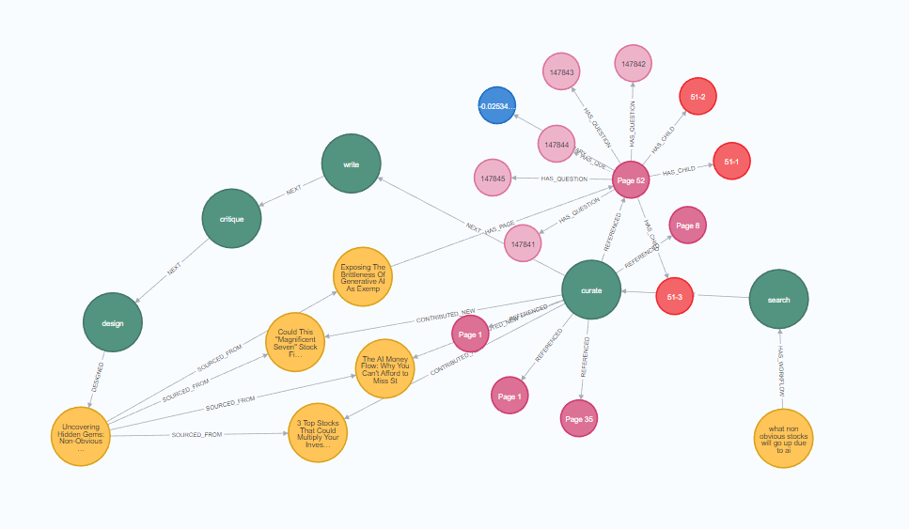

This is extremely useful as it shows clearly all sources, steps and actions taken to produce the output. This telemetry can be used to provide these details to the user, who can then assess the relevance and accuracy of the research by reviewing the sources – very much like references provided in a scientific journal.

One of the things that became apparent very quickly is that while the agents themselves and the pattern functions well, providing sufficient context for the agents is critical. In this case of this particular workflow, the objective is to research the topics provided. However, the pattern is highly dependent on how the search agent interprets the topic.

A specific example of how this can go wrong was when I asked the agent to research “AutoGen” which is a type of AI agent. The search agent interpreted ‘Auto’ in the context of ‘Autonomous Vehicles’ not in the context of ‘AI Agents’. The subsequent articles and thus the output was therefore not what I was actually looking for, which meant the tokens used to generate the results were not well spent.

Cost is another factor when developing AI agents. It can be difficult to get a sense of what the costs of an AI based agent workflow will be. It is critical to test each workflow step to determine costs, and optimize these where possible by targeting the appropriate model for the step. Its also crucial to bound conditional logic, number of sources and length of sources.

An example of this is the Writer-Editor feedback loop. This is a potentially expensive step if its not properly bounded.

### Outcomes:

Having a dashboard that provides projected cost of an agent run would be useful, as would tracking costs of each agent run in the resulting graph.

The ability to provide context directives to the agent at the outset of research or context generation workflows to anchor the agent in the correct context. Here having the agent perform an initial step to check what the user means would likely be useful. This would entail having a validation agent that interprets the user’s directive, but before executing the rest of the workflow, check back in with the user:

* User: Research AutoGen
* ValidationAgent: AutoGen= Autonomous Vehicle is this a correct interpretation?
* User: No – I meant AutoGen as in the Microsoft autonomous agent project
* ValidationAgent: Understood: Will initiation research on topic AutoGen the Microsoft autonomous agent platform

# Long Term Objectives:

This next-generation system begins with the user speaking to a smart device, such as a smart speaker or an AI-enabled smartphone, to record memories. The conversational AI, equipped with sophisticated natural language processing (NLP), listens and comprehends the user’s speech. Users can also utilize visual and audio inputs by showing photos or videos to the device’s camera, with multimodal AI processing these inputs to enhance memory capture. For those who prefer typing, the system offers real-time transcription and context-aware suggestions to ensure accuracy.

Once memories are captured, the AI automatically categorizes and tags them based on context, date, and content, creating a structured and organized memory vault. Secure cloud storage ensures these memories are safely backed up and accessible from any device. This intelligent memory vault presents memories in an easily navigable interface, complete with text and visual thumbnails, providing a user-friendly experience. The AI can also prompt users to review their updated memory vault, helping them stay engaged with their stored memories.

Retrieving memories is simplified through natural language voice commands. Users can ask the AI to show specific memories, and advanced search algorithms understand these queries and retrieve the relevant data. The contextual search feature allows users to describe the context or content they recall, and the AI retrieves corresponding memories. Additionally, a visual interface enables users to browse through their memory vault, with the AI highlighting and suggesting relevant memories based on recent activities and preferences.

When it comes to writing memoirs, the AI offers comprehensive assistance. Users can dictate or write drafts, with the AI providing real-time suggestions, grammar corrections, and enhancements. The system facilitates the incorporation of stored memories into the writing, seamlessly integrating text, images, and videos from the memory vault. Over time, the AI learns the user’s writing style and preferences, offering increasingly personalized assistance. Finally, the AI helps users review and edit their drafts, ensuring consistency and a well-structured narrative.